Overseas Internship Diary | Toh Yu Xuan: Winter Wonders and Quantum Quests
Published on January 8, 2024
Department of Physics
Name: Toh Yu Xuan
Programme: Physics
Intake: 2021/04
Internship place: Institute of Theoretical Physics and Astrophysics, University of Gdansk, Poland
Internship period: Sep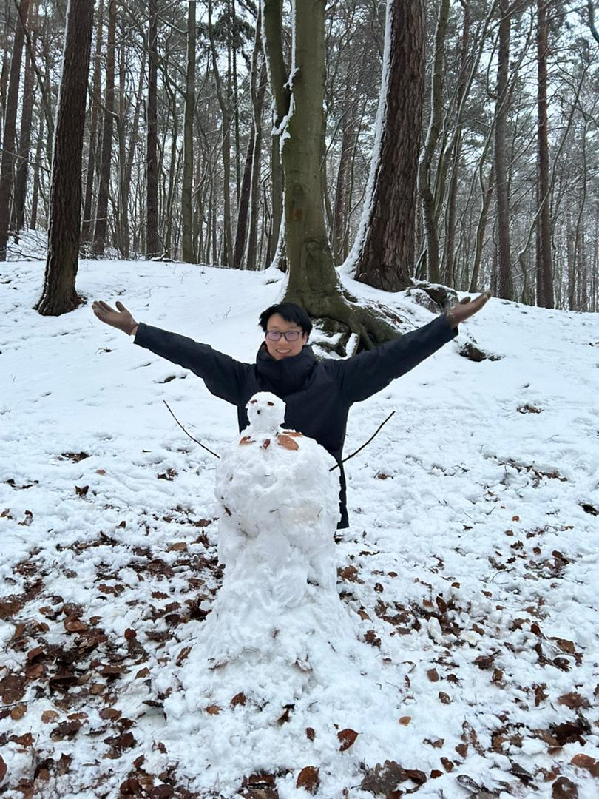tember to December 2023
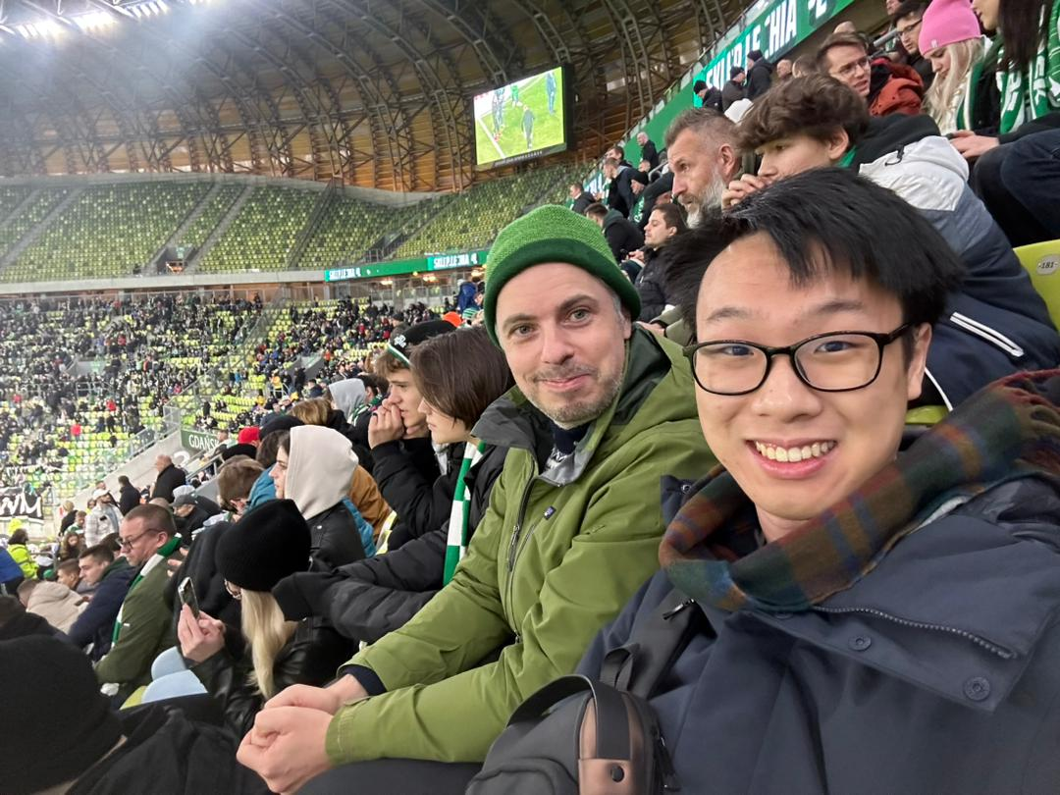
My name is Yu Xuan and at the time of writing this I am currently a year 3 student finishing his internship/ undergraduate research II at the University of Gdansk in Poland.
It has been a few months since I arrived in Gdansk and I got to say that my life has been fantastic here. The first thing I would like to share is that as a 21-year-old kid born and raised in Malaysia, I have the chance to witness and touch snow for the very first time in my life, which is truly incredible. The texture of snow is exactly the same as the shaved ice in cendol dessert in Malaysia, where our only 3 seasons are hot, hotter, and even hotter.
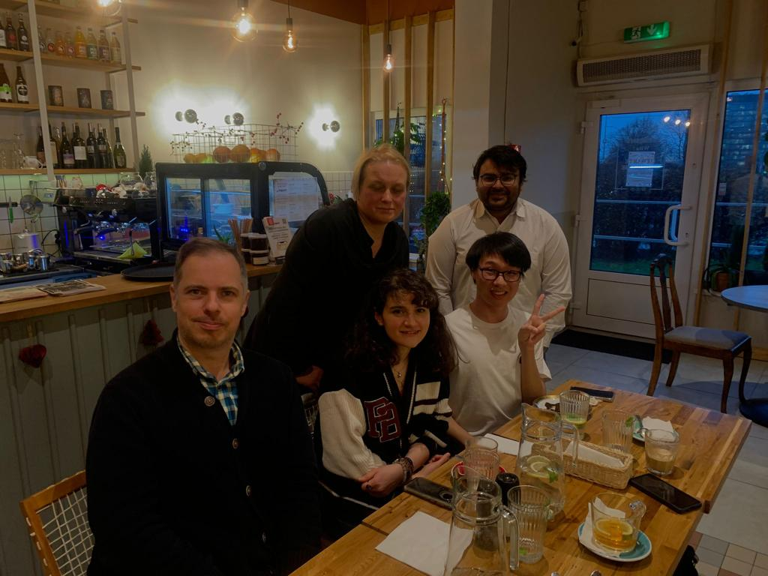
The title of my research with Dr. Thomas Zlosnik is "Action Integral and Newton-Cartan Theory". Action integral is an integral used in Physics like a dictionary that stores the Physics concepts of a system which can be extracted from (e.g. equations of motion of a particle, conservation laws, and more), provided that we know the Lagrangian of the system. Newton-Cartan theory allows expressing Newtonian gravity equations with spacetime symmetries similar to Einstein's General Relativity.
The question is, can we write out an action in a way such that the equations of Newton-Cartan theory can be extracted from it? So far, such integral has not been discovered in our research. However, we have comprehended and developed all the essential tools and mathematics needed to unveil its form in the future.
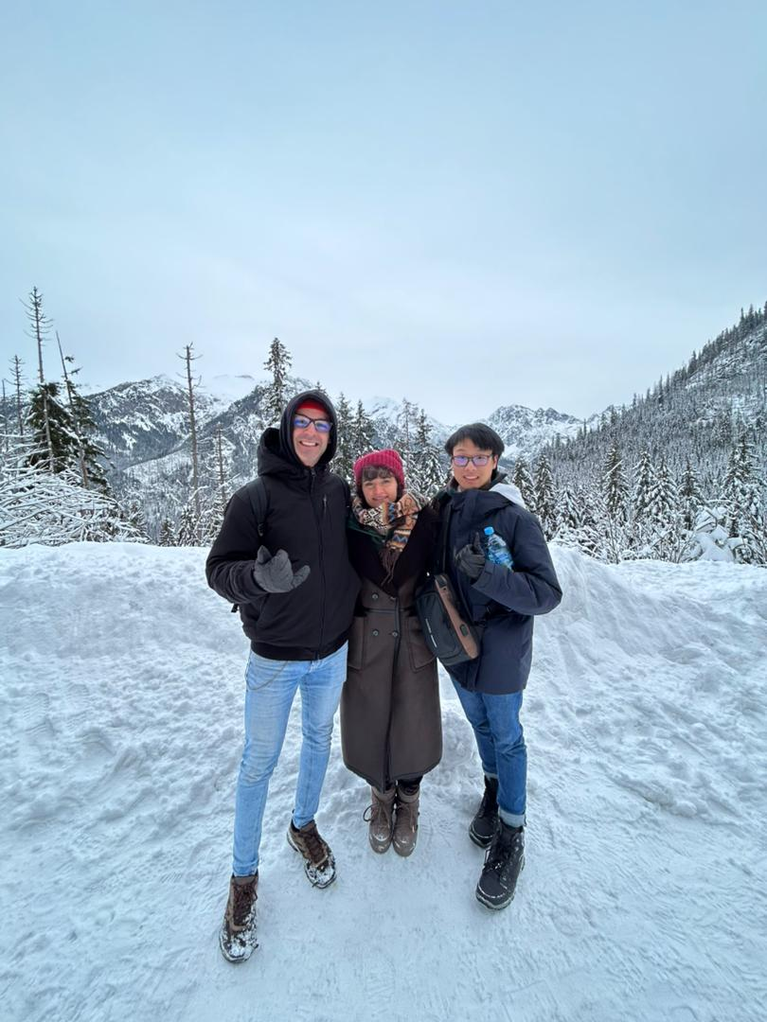
Another thing I enjoyed during my stay is the community I am in. In the department, there are Master’s and PhD defenses once a while and I did participate in one of the Master's defense and a few Physics talks. These events give me a clearer image of what to expect in graduate school in the coming years.
Sometimes I would go out for dinner gatherings with my team members and try dishes I have never seen before (and they do taste incredible). I have also experienced my first ever soccer match as an audience in the arena with Dr. Zlosnik at Polsat Arena Gdansk. It was remarkable to watch the players playing the match this close to my very eyes and be surrounded by the cheering from the fans.
Last but not least, the most precious memory that will always have a special place in my heart until the entropy of our universe reaches its maximum is the time with all the amazing friends I have made here. All of us come from different parts of the world and somehow all the eigenstates collapsed into this outcome that we are able to meet together in this one spot in this moment.
We have done a lot of stuff that is too long to be all written here. Weekly Friday night gatherings, going to escape rooms, speedrunning the entire Harry Potter movie series in a month, wrestling in the snow and having snowball fights whenever someone squats down. We went from Gdansk (North part of Poland) all the way to Zakopane (South part of Poland), hiking, snowboarding and skiing, campfire with sausages and cheese, and many more that are too long to be fitted in here. "Borrowing a quote from some yellow bear, We didn't realize we were making memories; we just knew we were having fun." - Winnie the Pooh.
This semester has been the greatest and the happiest one for me in my entire university life as a Physics student. I am very grateful to everyone who has made it possible for me to come here for my internship/ undergraduate research II.

